CAREER OPPORTUNITIES: LOOKING FOR…

Expanded Operational Stress Control (E-OSC) Team Leaders (CPO And Above)

Assistant Team Leaders (PO1 And Above)

Team Members (PO2 And Above)

To Assist In Ensuring Personal Readiness And Combat Effectiveness Onboard “USS XXXXXXX”.
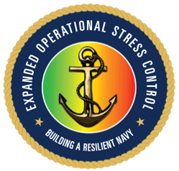  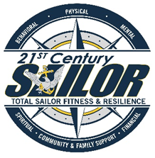 |  | What is E-OSC?  The E-OSC program is intended to provide leaders at all levels the foundation to understand the value of building and preserving resilience in Sailors. This foundation enables Leaders to recognize, manage & mitigate combat and operational stressors & stress reactions in themselves and their Sailors.  The program aims to enhance or add to the Leaders toolset, individual and organizational resilience skills to be taught to their Sailors and highlight why these skills are so important to their well-being.  The E-OSC program will inform, empower and encourage the Navy community of Sailors, civilians and their families to identify signs of stress within themselves and others and know how to help themselves and their peers or where to turn for help.  E-OSC Team Leaders, Asst. Team Leaders and Team Members will be trained & in turn, “stand-up” or be included in a team of highly motivated individuals as the Command E-OSC Team. This Team will work side by side with the CRT, leadership and other motivators to further assist “USS XXXXXXX” Sailors in ensuring WE ARE READY by addressing resilience and stress from all angles through training, mentorship and comradery. Mission First, Sailors Always.

